Gradient Boosting Algorithms

1. What is Gradient Boosting, and How Would You Define it?
Gradient Boosting is a boosting algorithm, which works on the concept of the stagewise addition method, where many weak learners are trained, and in the end, we get strong learners as a result.
In gradient boosting, a particular weak learner is trained on the dataset, and the errors or mistakes made by the algorithm are noted. Now while training a second weak learner algorithm, the errors and the mistakes that are made by the previous algorithm is passed into the second weak learner algorithm to avoid the same mistake.

2. How Does Gradient Boosting Algorithm Work?
Since the gradient boosting algorithm is a boosting algorithm, the error rate from previous models is calculated and passed to the next models to reduce the overall error rates.

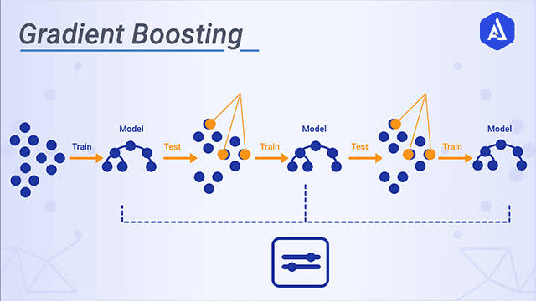Source – Google
In gradient Boosting regression problems, the prediction of the first model is always the mean of the target training data.
For Example, if the target variable is an age where various numbers are stored, then the output from the first weak learner will be the mean of all age values from the target column.
Once we have the prediction column from the first weak learner, the residual or error is calculated for the first model, which will be the difference between the actual and predicted value. Now while training the second model or a weak learner, the training data will be the same as model 1 training data, but the target column would be the residual column from weak learner model 1. So here, the residuals will be used as the target variables, and the model will be trained on that.
Once model 2 is trained, the prediction will be calculated for model 2, and the residuals will be again calculated for the same. The same process is done until we reach zero values for the residual column.

3. What is the Reason Behind Not Using Decision Stumps as Algorithms for Gradient Boosting?
Research has proven that using decision stumps as weak learner algorithms for AdaBoost gives good results, but in Gradient Boosting, using decision stumps as weak results does not give reliable results.
However, in Scikit-Learn, by tuning the value of max_lead_nodes we can easily modify the max depth of the decision trees.
from sklearn.tree import DecisionTreeRegressor
Tree = DecisionTreeRegressor(max_leaf_nodes=8)
However, research has proven that the value of max_leaf_nodes between 8 to 32 gives the best results for the gradient boosting algorithm.

4. What are the Assumptions of the Gradient Boosting Algorithm?
There are certain assumptions taken while using the Gradient Boosting algorithm, which is as follows
1. The training dataset is present in the form of numerical or categorical data
2. The loss functions which is being used for calculating residuals should be differential at all points
3. There is no restriction for the number of iterations running to achieve zero residual values.

5. How Can You Improve the Performance of the Gradient Boosting Algorithm?
There is not any doubt about the performance of the Gradient Boosting algorithm. However, still, there are some ways and parameters associated with the algorithm, tuning in which the performance of the gradient boosting algorithm should be enhanced.
1. Increasing max-leaf nodes for the algorithm increases the decision tree’s depth as a weak learner, which might also increase the performance of the gradient boosting algorithm in some cases.
2. Increase the number of iterations.
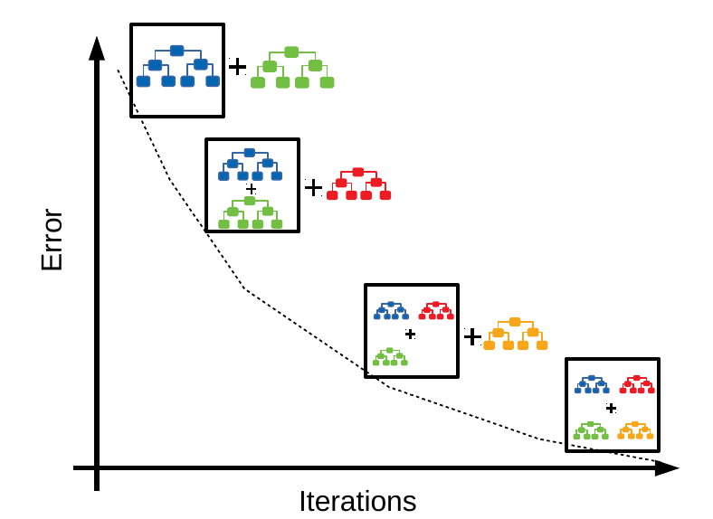Source – Google
3. Choosing a lower learning rate between 0.1 to 0.4 might increase the accuracy of the gradient boosting algorithm.
4. Random sampling can also help achieve a higher performance of the models.
5. Implementing the regularization techniques can also help get better accuracies from the model.

6. What are the Advantages of Using the Gradient Boosting Algorithm?
Advantages
1. Handling missing data while using a gradient-boosting algorithm is very easy.
2. Gradient Boosting algorithm performs best on both categorical and numerical data. Hence there is no need for much data preprocessing.
3. The performance of any data is outstanding and provides higher accuracy.

7. What are the Disadvantages of the Gradient Boosting Algorithm?
Disadvantages
1. Gradient Boosting algorithm is not robust to the outliers; hence, they are affected by outliers most and cause overfitting.
2. There is a higher power complexity in this algorithm as many decision trees are trained in this algorithm.
3. Since many calculations are present in this algorithm, It is time-consuming, and a higher time complexity is associated with it.
4. They are not user-friendly to understand, and very hard to interpret the results and parameters.

8. How is Gradient Boosting Different From XGBoost?
XGBoost is also a boosting algorithm in machine learning which is an extreme version of gradient boosting.
In gradient boosting, there is no implementation of regularization, whereas XGBoost is a regularized form of gradient boosting algorithm, where L2 or L1 regularization is already implemented.

9. What is the difference between Gradient Boosting and Random Forest?
The basic difference between gradient boosting and the random forest is that gradient boosting is a boosting algorithm that uses the stepwise addition method for weak learners. In contrast, the random forest is a booting algorithm that uses decision trees as a base model.
Gradient boosting is slow compared to the random forest, as much time is needed to train decision trees sequentially. In contrast, random forest is faster compared to the gradient boosting algorithm.
There are weak learners involved in gradient boosting, so it is a high-bias and low-variance algorithm. In random forests, due to fully grown decision trees, there might be a higher chance of overfitting; hence they are low-bias and high-variance models.

10. Why does Gradient Boosting perform so well? State 3 points.
1. Power of Crowd: Gradient Boosting is a stagewise addition method, which means it learns from the crowd of weak learners, and history says that the crowd is always right.
2. No repetition of mistakes: Once a particular weak learner is trained, the next weak learner is trained with preparation for not making the same mistake again.
3. Decision Trees and Tuning: We already know that decision trees are one of the best algorithms with high performance on any dataset; in Gradient Boosting, decision trees are used mainly as weak learners, which is also a reason behind the good performance of the gradient boosting algorithm.

11. Difference between Adaboost and Gradient Boosting
The difference between AdaBoost and gradient boosting are as follows:
AdaBoost | Gradient Boosting
During each iteration in AdaBoost, the weights of incorrectly classified samples are increased, so that the next weak learner focuses more on these samples. | Gradient Boosting updates the weights by computing the negative gradient of the loss function with respect to the predicted output.
AdaBoost uses simple decision trees with one split known as the decision stumps of weak learners. | Gradient Boosting can use a wide range of base learners, such as decision trees, and linear models.
AdaBoost is more susceptible to noise and outliers in the data, as it assigns high weights to misclassified samples | Gradient Boosting is generally more robust, as it updates the weights based on the gradients, which are less sensitive to outliers.

12. what is boosting in machine learning
Boosting is a powerful ensemble technique in machine learning that aims to improve the accuracy of models by combining the performance of multiple weak learners to create a strong learner. A weak learner is typically a model that performs slightly better than random guessing. The core idea of boosting is to train these weak learners sequentially, each focusing more on the mistakes made by the previous learners.

How Boosting Works
- Initialize Weights: Begin by initializing the weights of the training data equally.
- Train Weak Learner: Train a weak learner (e.g., a decision tree with limited depth) on the training data.
- Compute Error: Calculate the error of the weak learner on the training data.
- Update Weights: Adjust the weights of the training instances. Increase the weights of the instances that were misclassified by the weak learner, so that these instances receive more focus in the next round.
- Combine Learners: Repeat steps 2-4 for a specified number of iterations or until a certain performance level is achieved. The final model is a weighted combination of all the weak learners.

Key Boosting Algorithms

1. AdaBoost (Adaptive Boosting)
AdaBoost is one of the earliest and most well-known boosting algorithms. It adjusts the weights of misclassified instances so that subsequent weak learners focus more on difficult cases.
- Algorithm:
  - Assign initial weights to all training samples.
  - For each iteration, train a weak learner.
  - Compute the weak learner's error rate.
  - Update the weights of the training samples based on the error rate.
  - Combine the weak learners into a final strong learner.

2. Gradient Boosting
Gradient Boosting builds models sequentially by optimizing a loss function. Each new model minimizes the residual errors (the difference between the actual and predicted values) of the previous models.
- Algorithm:
  - Initialize the model with a constant value (e.g., the mean of the target variable).
  - For each iteration, compute the residual errors.
  - Train a weak learner on the residuals.
  - Add the predictions of the weak learner to the model, adjusting based on a learning rate.
  - Repeat until a specified number of iterations or convergence.

3. XGBoost (Extreme Gradient Boosting)
XGBoost is an efficient and scalable implementation of gradient boosting. It includes several optimizations such as regularization, sparsity awareness, and parallel tree construction.
- Features:
  - Regularization to prevent overfitting.
  - Built-in cross-validation.
  - Efficient handling of missing data.
  - Tree pruning to prevent overfitting.
  - Parallel processing for faster training.

4. LightGBM
LightGBM is another gradient boosting framework that is designed for speed and efficiency. It uses a histogram-based approach and grows trees leaf-wise rather than level-wise.
- Features:
  - Gradient-based One-Side Sampling (GOSS) for handling large datasets.
  - Exclusive Feature Bundling (EFB) to reduce the number of features.
  - Leaf-wise tree growth for better accuracy.

5. CatBoost
CatBoost is designed to handle categorical features directly and is particularly effective with datasets that have categorical variables.
- Features:
  - Handles categorical features without preprocessing.
  - Efficient training with ordered boosting.
  - Robust to overfitting and provides strong performance on various datasets.

Advantages of Boosting
- Improved Accuracy: Boosting can significantly improve the accuracy of weak learners.
- Versatility: Works well with various types of data and models.
- Robustness: Effective in reducing both bias and variance, leading to better generalization.

Disadvantages of Boosting
- Computationally Intensive: Sequential training of weak learners can be time-consuming.
- Overfitting: If not carefully regulated, boosting can lead to overfitting, especially with noisy data.
- Complexity: The final model can be complex and difficult to interpret.
Boosting is a versatile and powerful tool in machine learning, widely used in many applications to enhance predictive performance.

